Water Infographic - Analysis Practice

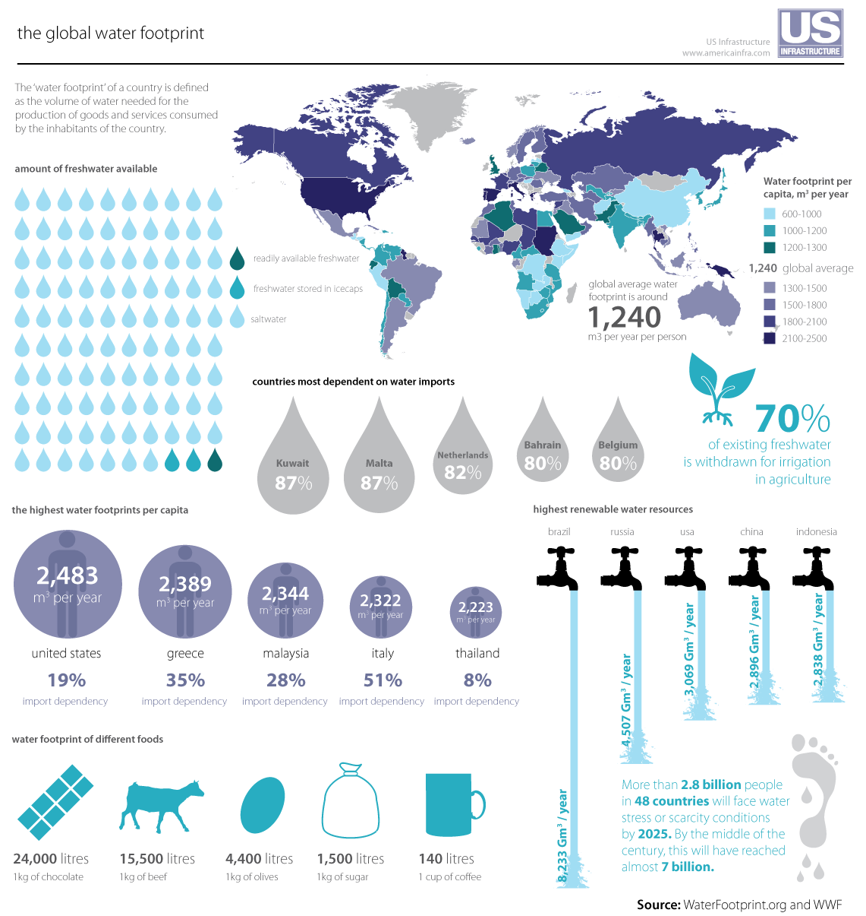

Task: Study the infographic and answer the following questions:

- Identify one country excluding the USA with a high water footprint (1)

- State what you consider to be the main message of the infographic (1)

- Use evidence to justify your answer to question 1 (2)

- Evaluate the effectiveness of the infographic (6)

