Reading: Ecological footprints

The graphic below, from the UN Global Resource Outlook report, shows a worrying rate of resource depletion resulting from population growth and economic development since 1970. This growth in development has led to a 340% increase in global mineral extraction. An increase from 27 billion tonnes a year to 92 billion tonnes a year. Demand for material goods in the same time frame has increased from 7.4 tonnes per person to 12.2 tonnes per person.
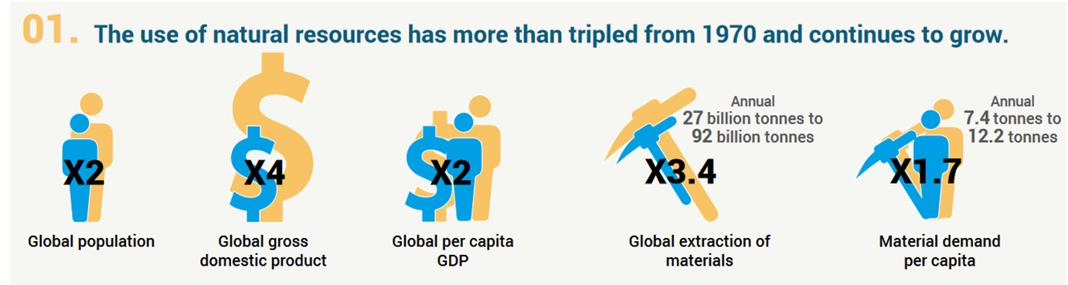
If the world is to successfully reduce its rate of resource consumption, each individual, organisation, city, region and country needs to have an effective tool for measuring their impact on the resources of the planet. One such measuring tool is ecological footprint.
The Global Footprint Network defines Ecological footprint as measuring the ecological assets that a given population requires to produce the natural resources it consumes. This includes all plant-based food and fibre products, livestock and fish products, timber and other forest products and space for urban infrastructure. It also measures the ability of the biocapacity to absorb its waste, especially carbon emissions. The Ecological Footprint tracks the use of six categories of productive surface areas: cropland, grazing land, fishing grounds, built-up land, forest area, and carbon demand on land.
The Global Footprint Network claim that Ecological Footprint is the only metric that measures how much nature we have and how much nature we use. At the national scale it can support countries to become sustainable and improve human well being. At the city and regional scale it can help inform major public project investments. At the household scale it helps individuals understand the impact their lifestyle has on the planet and helps them target individual efforts to reduce it.
To help communicate and visualise Ecological Footprint, The Global Footprint Network has developed a concept called World Overshoot Day. This presents the day in the year that each country, based on its own rate of resource consumption would overshoot the world's capacity to support it, if every country consumed at that rate. With each country combined, it's possible to identify a day in the year that the world overshoots its capacity.
The data presented above shows how the World Overshoot Day has been arriving earlier each year since 1970 and the map shows how each country's ecological footprint has
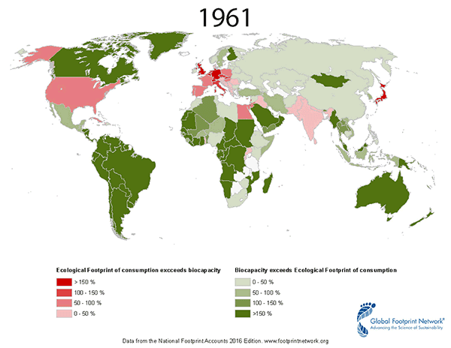
increased over time between 1961 to 2012. It is clear to see how most of North Africa, The Middle East and Asia moves from not exceeding its biocapacity to exceeding it by more than 150%.
Ecological Footprint for Individuals: Individuals can use an ecological footprint calculator to measure the impact of their own lifestyle on the planet's resources. Such calculators provide a highly simplified measure of an individual's resource consumption and should be seen as an educational tool rather than a complex and comprehensive measure. The purpose of the calculators is to help individuals visualise the scale of their impact and focus their attention and action on reducing their impact in certain key areas. The following screenshots show the result of the author's calculation.
Localising Ecological Footprint: There is a strong argument that ecological footprint is best used at the city and regional scale, after all, projections suggest that between 70-80% of the world's population will live in cities by 2050. Cities also represent a huge amount of an individual country's ecological footprint. Cities also tend to have significantly higher footprints than the average for their country.
Ecological Footprint at the National Scale: It is also possible to apply Ecological Footprint as a tool for measuring resource impact at the national scale. Governments can benefit from the metric as it is an accurate measure of resource use and can guide their policies towards sustainable development. In December 2006, Switzerland became the first country in the world to complete a review of its National Footprint accounts. The government published the review as a report titled Switzerland’s Ecological Footprint—A Contribution to the Sustainability Debate. INFRAS, a leading Swiss policy research institute that wrote the report, compared the international data sources used by Global Footprint Network to the statistics used by the Swiss Federal Statistical Office, and concluded that the data sets were largely consistent.
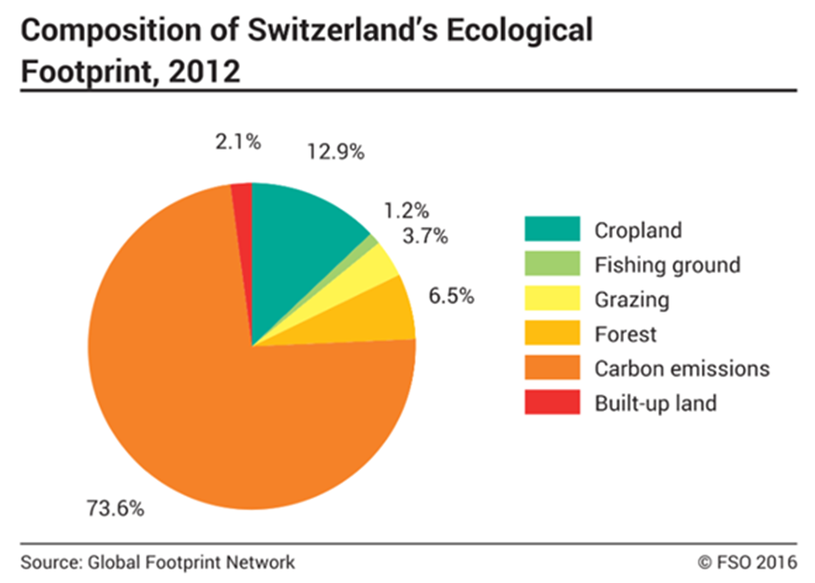

Ecological Footprint at the Global Scale: By having a metric, that can accurately measure both the resource demand of a country and its own biocapacity to provide for it, it is useful to support government planning towards long term sustainable development goals that improve the well being of their population.
The graphic to the below shows a comparison across countries. For example, South Korea needs 8.8 South Koreas to provide the biocapacity to support its demand on world resources. In contrast, the US, which has one of the biggest per capita ecological footprints in the world only needs 2.3 Unites States of America to fulfil its own pressure on biocapacity. Countries with small land areas clearly overshoot. Luxembourg for example has the largest ecological footprint in Europe.
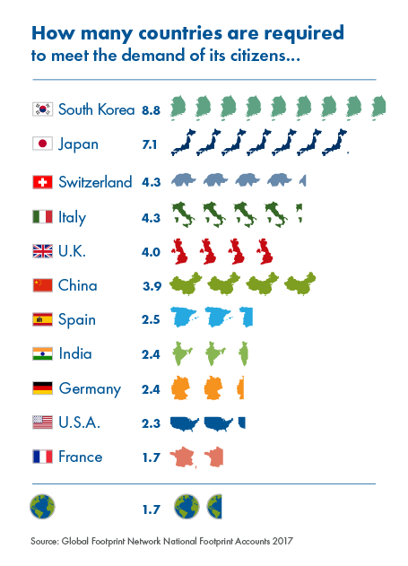
The United Nations can support these efforts and is doing so, within global frameworks such as the Sustainable Development Goals but at the end of the day, these goals need national policies and actions to be met. National polices are best achieved through ecological footprint metrics at the city and regional scale, where largest demand on resources is located. By localising action it also prioritises the role of households and individuals. We as individuals all have an important role to play in making lasting efforts to reduce the pressure on the planet's finite resources. We can only do this through behavioural change in our consumption of commodities and material goods and Ecological Footprint can play a key role in informing us of where to make those changes.
Source: InThinking

