Ocean Odyssey
Where, What, Whose?
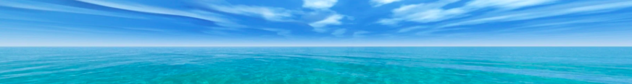

Aim: The aim of this activity is to explore various aspects of the ocean to learn more about its natural and human systems. As we go through this activity you need to use your map to record information and take notes on this worksheet or in your book.

When you record information on a map you may need to do two things:

- Create a map key: A map key or legend is included with a map to unlock it. It gives you the information needed for the map to make sense. Maps often use symbols or colors to represent things, and the map key explains what they mean.
- Annotate your map: An annotation is a brief sentence, descriptive and/or explanation, applied to a particular feature or features on a map. Annotations are often contained in small boxes and are short and concise (maybe 10 words maximum)

Part 1: Where

Oceans

On your A3 map mark in:

- The 5 main oceans
- Draw a dotted line to show the approximate boundaries of each ocean

Ocean Facts
Go to this webpage or article Make a note of two interesting facts for each of the oceans.
Ocean | Facts
Pacific
Atlantic
Indian
Arctic
Southern

Now have a go at this quiz labeling world oceans and seas.

b. Megacities

Use the map of megacities below to complete the following:

Name and label these megacities: on your outline map
- Tokyo
- Shanghai
- New York
- Singapore
- Mumbai
- Cairo
- Bangkok
- Lagos

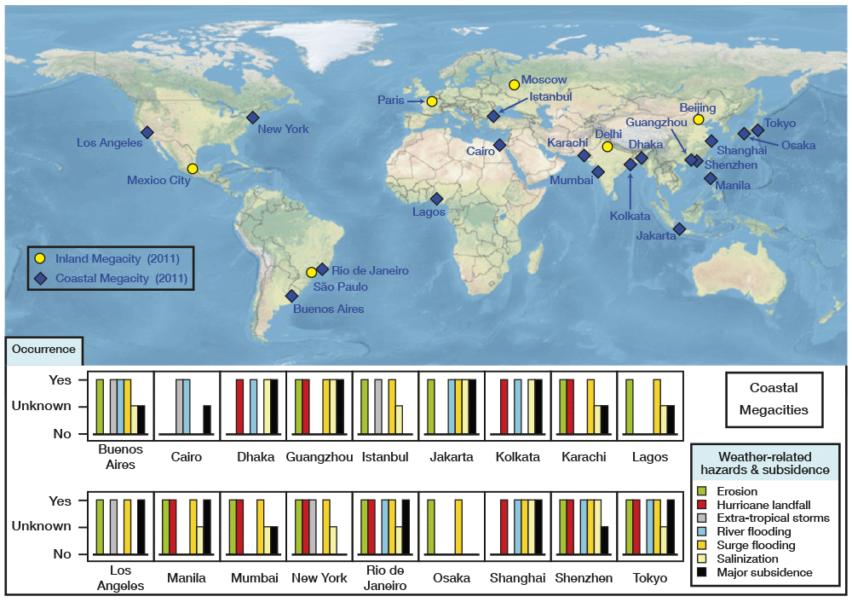

Megacities
What is a megacity?
Why are so many mega-cities coastal?
What kinds of hazards are these cities especially vulnerable to?
Go to this map and comment on what happens to the following cities with 2 or 4 degrees of global warming
Shanghai
New York
Bangkok

Part 2: What?

- Fishing:

Fishing
Go to this website. Make a note of two interesting facts for each of the oceans relating to fishing. For example, species present, or issues relating with fishing.
Ocean | Facts
Pacific
Atlantic
Indian
Arctic
Southern
Now look at the map of fish catch levels below and comment on:
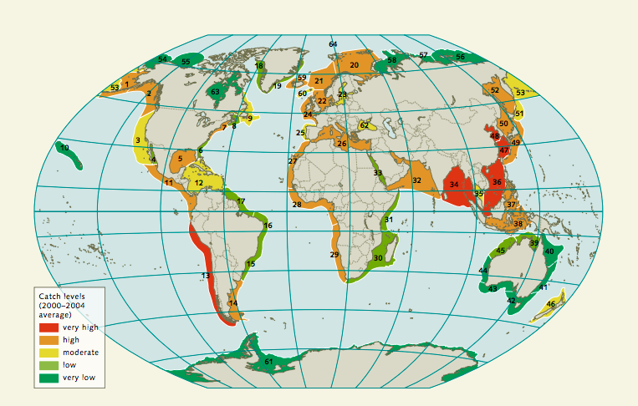
Which areas have the highest catch levels? (you can also mark on your map)
Why do those places have high catch levels?
Why do some areas have low catch levels?
Read this article and then list the top 5 countries in terms of total catch (map your findings)
State what % of protein consumed is through eating fish
B. Abiotic Ocean Resources:

Abiotic ocean resources are non-living parts of the ocean ecosystem.

Oil
Oil: On your map locate the North sea oil fields and the site of the Deepwater Horizon. Then answer the questions below
A few decades ago Norway was one of the poorest countries in Europe. Now it is the top ranked country in the UN Development index. Why is Norway such a wealthy country?
What was the Deep Water Horizon incident and what impacts did it have on the environment?

Minerals
Go to this website and show on your map locations where manganese nodules are found
Explain where methane hydrates are found.
Use this BBC article to answer these questions:
Why are some companies keen to start deep sea mining?
What are some potential problems with deep sea mining?

Resources
Read this article and list:
Countries that are claiming rights to resources in the Arctic
Resources that are becoming available due to the melting of Arctic ice.

Part 3: Whose?

Geopolitics: Geopolitics focuses on political power linked to geographic space. In oceans, it refers to territorial waters and control of ocean passages and resources. For each of these geopolitical features locate and label their location then note in the table below why they are important.

Geopolitical Feature | Importance
The Suez and Panama Canals
The Straits of Mallacca
Strait of Gibraltar
Fiery Cross Reef
The Straits of Hormuz
Define these Terms
Sovereignty
UNCLOS
EEZs
Take Notes from the VOX video on the conflict in the South China Sea

