The Changing Role of Oceans as a Store and Source of CO2

The Oceans and the Carbon Cycle

Oceans as a Carbon Sink: Oceans play a critical role in regulating the Earth’s carbon cycle. They absorb about 25-30% of the carbon dioxide (CO2) released by human activities, particularly from fossil fuel combustion and deforestation. This process helps mitigate climate change by temporarily storing CO2. CO2 dissolves in seawater and is taken up by marine plants like phytoplankton through photosynthesis. Oceans are thus considered one of the largest carbon sinks.

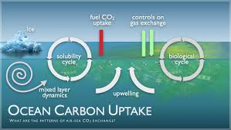

Oceans as a Carbon Source: However, the oceans can also release CO2 back into the atmosphere, especially when water temperatures rise. Warmer waters hold less CO2, meaning that as global temperatures increase due to climate change, the oceans’ ability to act as a carbon sink is reduced. This process is sometimes referred to as “outgassing” and could potentially accelerate global warming by reducing the ocean’s carbon storage capacity.

Key Concepts:
• Carbon Sink: A natural environment that absorbs more carbon than it releases.
• Outgassing: The release of gases, such as CO2, from the ocean back into the atmosphere.

Example: The Southern Ocean, surrounding Antarctica, absorbs large quantities of CO2, but recent studies suggest that warming waters are beginning to release more CO2, reducing its effectiveness as a carbon sink.

The Impacts of Ocean Acidification on Coral Reefs

Ocean Acidification Explained: When CO2 is absorbed by seawater, it reacts to form carbonic acid, lowering the pH of the ocean—a process known as ocean acidification. Since the industrial revolution, the ocean’s pH has dropped by about 0.1 units, making it more acidic. This process reduces the availability of carbonate ions, which are crucial for marine organisms like corals and shellfish to build their skeletons and shells.

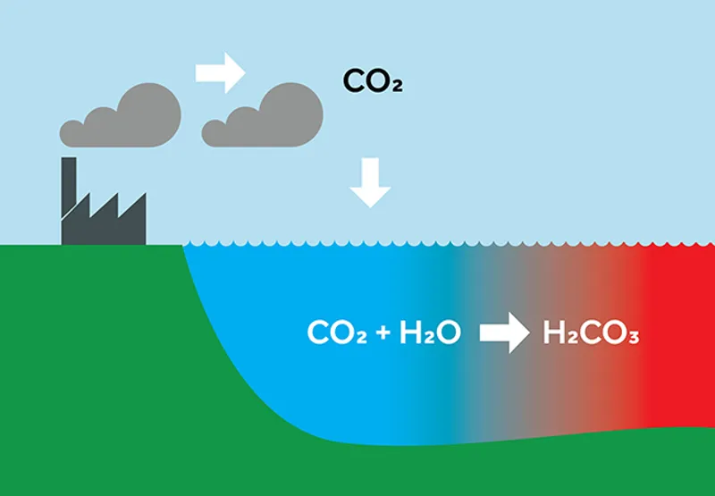

Impact on Coral Reefs: Coral reefs, often called the “rainforests of the sea,” are particularly vulnerable to acidification. They rely on calcium carbonate to grow and maintain their structures. As ocean acidification progresses, corals struggle to produce their skeletons, leading to weaker reefs, reduced biodiversity, and a loss of habitat for many marine species.

Examples:
• The Great Barrier Reef in Australia is experiencing bleaching events more frequently due to a combination of ocean warming and acidification. Coral bleaching occurs when corals expel the algae (zooxanthellae) living in their tissues, causing them to turn white and become more vulnerable to stress.
• Pacific Island reefs, crucial for the livelihoods of coastal communities, are showing signs of decreased calcification rates, directly linked to increasing ocean acidity.

Key Concepts:
• Ocean Acidification: The reduction in the pH of the ocean due to increased CO2 absorption.
• Coral Bleaching: A phenomenon where corals lose their vibrant colors due to environmental stress, often related to temperature and acidity changes.
• Calcification: The process by which marine organisms build their skeletons or shells using calcium carbonate.

Conclusion: The role of oceans as a carbon sink is essential for regulating global CO2 levels, but climate change threatens this balance. Ocean acidification, a direct consequence of increased CO2 absorption, poses a significant threat to coral reefs, impacting marine biodiversity and the communities dependent on these ecosystems. This underscores the need for stronger global action to reduce CO2 emissions and protect marine life.

