Reading: Sand Dune Development & Their Role in Coastal Protection

Introduction: Sand dunes are dynamic landforms found in coastal regions around the world. These ridges or mounds of sand are formed by the interaction of wind, water, and vegetation, and they play a crucial role in coastal ecosystems. Understanding the processes that lead to dune formation, as well as their importance in protecting coastlines, is key to understanding both natural coastal defenses and the human impact on fragile environments.

Conditions Necessary for Sand Dune Formation: For sand dunes to form, several conditions must be met:
- Abundant Supply of Sand: Coastal areas with large amounts of loose, dry sand provide the essential material for dune formation. This sand is transported to the beach by marine processes.
- Wind: The wind is a key agent in sand dune formation. Strong, persistent winds blow sand inland from the beach, lifting it over the surface and depositing it in new locations.
- A Wide Beach: A flat, wide beach allows for wind-blown sand to accumulate before being trapped by obstacles like vegetation.
- Vegetation: Pioneer species like beach grass (e.g., Ammophila) play a critical role in dune formation. These plants trap moving sand with their roots, allowing dunes to build up over time.
- Dry Conditions: Sand dunes typically form in areas that are dry enough to allow sand particles to be lifted and carried by the wind, rather than being washed away by tides.

Process of Dune Formation
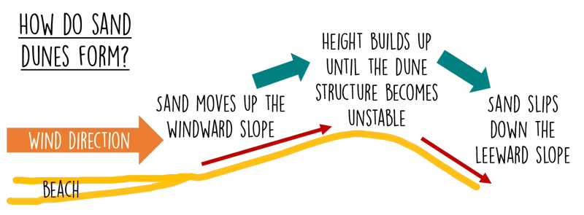
- Sand Transport: Wind picks up sand particles from the beach through a process called saltation, where sand grains are lifted and bounce along the surface. Larger particles may move through creep, sliding or rolling along the ground.
- Formation of Embryo Dunes: The initial dunes, known as embryo dunes, form when sand accumulates behind an obstacle, such as a piece of debris or vegetation. These small dunes serve as the foundation for larger dune systems.
- Growth of Dunes: As sand continues to accumulate and pioneer vegetation traps more sand, embryo dunes grow into larger foredunes. These dunes become more stable as vegetation establishes deeper roots, further anchoring the sand.
- Mature Dune Systems: Over time, dunes develop into complex systems with distinct zones, including foredunes, yellow dunes (closer to the beach and still growing), and grey dunes (older and covered with more stable vegetation). Further inland, climatic dunes may form in areas with sufficient moisture and plant cover.

Role of Sand Dunes in Coastal Protection: Sand dunes are a natural defense against coastal erosion and storm surges. By acting as barriers between the sea and inland areas, dunes help reduce the impact of:
- Storm Surges: Dunes act as buffers, absorbing the energy of waves and protecting inland infrastructure from flooding.
- Coastal Erosion: Wind and wave action constantly erode coastlines, but dunes help retain sand and reduce the speed at which beaches are eroded.
- Protection of Ecosystems: Coastal dunes provide habitats for various species of plants, insects, birds, and animals that are specially adapted to survive in these environments.

Impacts of Removing Sand Dunes: The removal of sand dunes, whether through natural forces like storms or human activities such as construction and tourism, can have devastating impacts on coastal areas. Without dunes, coastlines become vulnerable to:
• Increased Coastal Erosion: Without dunes to trap sand, erosion rates increase, leading to beach loss and damage to nearby structures.
• Flooding: Without the natural barrier that dunes provide, inland areas are more prone to flooding during storms and high tides.
• Loss of Biodiversity: Sand dunes are home to unique plant and animal species that are highly adapted to this environment. When dunes are removed, these species lose their habitat.

Example of Impact: The Removal of Dunes in New Jersey, USA: In New Jersey, the removal of sand dunes for beachfront development led to severe coastal erosion and flooding during Hurricane Sandy in 2012. The areas where dunes had been destroyed suffered far more damage than those with intact dune systems.

Example: Western Australia: In Western Australia, mining and development have removed many coastal dunes. Without dunes, local communities have seen increased coastal erosion, and the loss of natural habitats has endangered several species that rely on the dunes for survival.

Glossary of Key Terms:
• Saltation: The movement of sand particles in short hops or jumps caused by wind or water.
• Embryo Dunes: Small, initial sand dunes that form behind obstacles like vegetation.
• Foredunes: Larger, more stable dunes formed as sand accumulates and vegetation takes hold.
• Creep: The slow movement of larger sand particles along the surface.
• Coastal Erosion: The wearing away of the coastline due to wind, water, and human activities.
• Storm Surge: The rising of sea levels due to storms, often causing flooding in coastal areas.

