Reading: Physical Influences on Coastal Landscapes
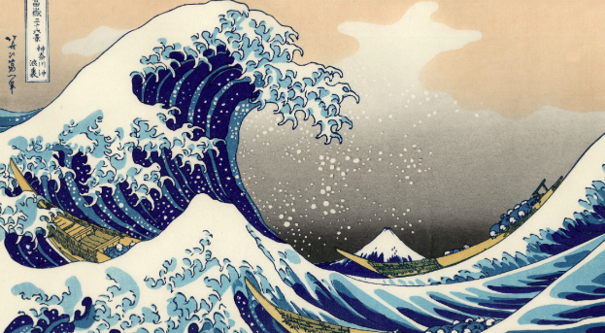
Introduction: Coastal landscapes are dynamic environments shaped by a variety of interacting physical influences. These influences work together to create distinctive landforms and to drive constant changes along the shoreline. Understanding how these processes interact is essential for explaining why coasts look the way they do and why they change over time.

Waves: Waves are one of the most important forces shaping coastal landscapes. They are generated by wind blowing across the surface of the sea, and their energy depends on factors such as wind speed, duration, and the “fetch” (distance over which the wind blows). Constructive waves, which have a strong swash and weaker backwash, build up beaches by depositing sediment. In contrast, destructive waves, with their strong backwash, erode coastlines and remove sediment from beaches. Over time, this balance between constructive and destructive waves influences whether a coastline is retreating, stable, or advancing.

Tides: Tides, the daily rise and fall of sea level caused by the gravitational pull of the moon and sun, determine how much of the coastline is exposed to wave action. A high tidal range means that a large area of the coast is affected, leading to wide intertidal zones where ecosystems such as mudflats, salt marshes, or mangroves may develop. Conversely, a low tidal range concentrates wave energy in a smaller zone, often intensifying erosion in that area. Tides therefore influence not only erosion and deposition but also the habitats that can form along the coast.

Sediment Supply: The availability of sediment is another key influence on coastal form. Sediment can come from rivers, cliff erosion, offshore sandbanks, or even human activities such as dredging. When sediment supply is abundant, beaches, spits, and bars are more likely to form. If sediment is limited, coastlines are more vulnerable to erosion. The balance between sediment being added and removed is referred to as the “sediment budget,” and disruptions to this balance—such as dam construction reducing river sediment—can accelerate coastal erosion.

Lithology: The type of rock, or lithology, that makes up a coastline has a major effect on its shape. Hard rocks like granite or chalk are more resistant to erosion and often form cliffs, headlands, and wave-cut platforms. Softer rocks such as clay or sandstone erode more quickly, producing bays, inlets, and low-lying coastlines. Differential erosion, where softer rocks erode faster than harder ones, creates distinctive coastal features such as headlands and bays. Lithology also affects how coastlines respond to wave attack and subaerial processes.

Vegetation: Coastal vegetation, from grasses and shrubs to mangroves and salt marsh plants, plays a protective role in stabilizing coastlines. Roots bind sediment and reduce the risk of erosion, while plant cover slows wind and water movement, encouraging deposition. For example, mangrove forests provide a natural barrier against storm surges, absorbing wave energy and trapping sediment. The presence or absence of vegetation can therefore determine whether a coast is resilient or fragile in the face of storms and rising sea levels.

Subaerial Processes: Subaerial processes refer to those that occur on land rather than directly in the sea. Weathering, such as freeze-thaw, salt crystallization, or chemical weathering, weakens rocks and makes them more susceptible to erosion. Mass movement, including landslides, rockfalls, or slumping, can rapidly alter coastal cliffs and feed sediment into the littoral system. These processes ensure that coastlines are not only shaped by the sea but also by atmospheric and terrestrial forces.

Wave Processes: Wave action operates through several key processes. Hydraulic action occurs when waves trap and compress air in cracks, eventually weakening and breaking apart rocks. Abrasion (or corrasion) happens when waves hurl sand, shingle, and larger rocks against the coastline, wearing it down like sandpaper. Attrition, where rocks and pebbles are smashed together, produces smaller, smoother sediment that contributes to beach material. In addition, longshore or littoral drift is the sideways movement of sediment along a coast due to waves approaching at an angle. This process redistributes material, creating landforms such as spits and barrier beaches. Together, these processes constantly erode, transport, and deposit material, reshaping coastlines over time.

Bringing It Together: Coastal landscapes are the product of a delicate balance between forces of erosion, transportation, and deposition, all influenced by natural conditions such as tides, waves, sediment supply, and geology. Vegetation and subaerial processes add further complexity, ensuring that no two coasts are exactly alike. Some coasts retreat rapidly under the combined pressure of destructive waves and limited sediment supply, while others advance through deposition encouraged by vegetation or tidal regimes. By understanding these physical influences, geographers can better explain the diversity of coastal forms and predict how coastlines might respond to future challenges such as sea-level rise and climate change.

