I Am Coral: Understanding the World of Coral Reefs
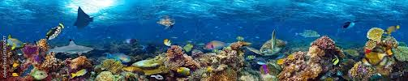

1. What Is Coral?: At first glance, colourful coral reefs might look like underwater gardens made of plants — but corals are actually animals. Corals are marine invertebrates that have existed for over 540 million years, making them some of the oldest living organisms on Earth.
Each coral is made up of tiny individual creatures called polyps. These polyps live together in large colonies, creating the hard, branching structures we see as reefs. Inside their tissues, polyps have a special partnership with microscopic algae called zooxanthellae. These algae photosynthesise, producing food for the coral and giving reefs their stunning colours.

2. Where Are Coral Reefs Found? Coral reefs grow in tropical and subtropical oceans around the world, mostly between the Tropic of Cancer and the Tropic of Capricorn. To survive, corals need very specific conditions:
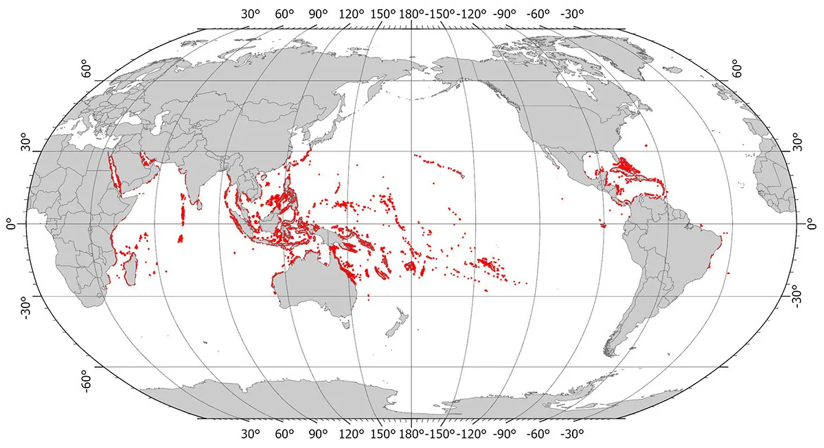
- Shallow water — usually less than 50 metres deep so sunlight can reach the algae inside the coral.
- Warm temperatures — typically between 23°C and 29°C.
- Clear water — away from river mouths and pollution, as sediment and silt can block sunlight.
Famous reef systems include the Great Barrier Reef in Australia, the Coral Triangle in Southeast Asia, and the Mesoamerican Reef near Mexico and Belize.

3. Types of Coral Reefs: Coral reefs come in three main forms:
- Fringing reefs – Found along coastlines, directly attached to the shore.
- Barrier reefs – Found further offshore, separated from land by deeper lagoons.
Atolls – Ring-shaped reefs that form around submerged volcanoes, creating lagoons in the centre.

4. The Importance of Coral Reefs: Although reefs cover less than 1% of the world’s oceans, they are home to an incredible 25% of all marine species. This makes them one of the most biodiverse ecosystems on the planet — even more diverse than tropical rainforests.

Ecosystem Services Provided by Coral Reefs: Coral reefs are essential to both nature and people. They provide:

a) Regulating Services
- Carbon storage: Reefs help absorb carbon from the atmosphere.
- Water filtration: Corals naturally clean ocean water.

b) Provisioning Services
- Food: Reefs supply fish and shellfish that feed billions globally.
- Jobs: The fishing and tourism industries depend on healthy reefs.
- Medicine: Many modern medicines are developed from reef organisms.

c) Cultural Services
- Tourism and recreation (diving, snorkelling, eco-tourism).
- Aesthetic beauty and inspiration for art and culture.

d) Supporting Services
- Fish nurseries: Reefs provide safe habitats for young fish.
- Coastal protection: Healthy reefs act as natural barriers against waves and storms, preventing coastal erosion.

5. Threats Facing Coral Reefs: Sadly, coral reefs are under increasing pressure from both local and global threats.

a) Local Threats
- Overfishing – Reduces fish populations and damages reef ecosystems.
- Pollution – Chemicals, plastics, and untreated sewage poison corals.
- Coastal development – Tourism and construction increase sediment and damage habitats.

b) Global Threats
- Climate change – Rising sea temperatures cause coral bleaching, where corals expel their algae and turn white.
- Ocean acidification – Increased carbon dioxide makes seawater more acidic, weakening coral skeletons.
- Sea-level rise – Alters light conditions, affecting coral growth.

6. Why Coral Reefs Matter for Our Future: Coral reefs are more than just beautiful underwater ecosystems; they are vital for human survival, climate stability, and marine biodiversity. Without urgent conservation efforts, scientists predict that up to 90% of coral reefs could disappear by 2050.

What Can We Do?
- Support sustainable fishing and avoid buying products that damage reefs.
- Reduce carbon emissions to slow climate change.
- Learn more about reefs and raise awareness about their importance.
- Be a responsible tourist — avoid touching corals, littering, or buying coral souvenirs.

