Kiribati – Case Study of Climate Migration

Syllabus Link

- Unit 2.3: Impacts of climate change on people and places, including migration
- Unit 1.2: Detailed examples of two or more forced movements, to include environmental and political push factors, and consequences for people and places

Task: Use the resources on adorngeo http://www.adorngeo.com/2-consequences-of-climate-change.html or linked to this document to complete a case study of Kiribati as an example of climate change and forced migration.

Start by watching the first 3 short videos on adorngeo to get an overview. The mind map below is also useful to get you thinking bout the case study. There is also a longer video, useful if you have time to watch it.

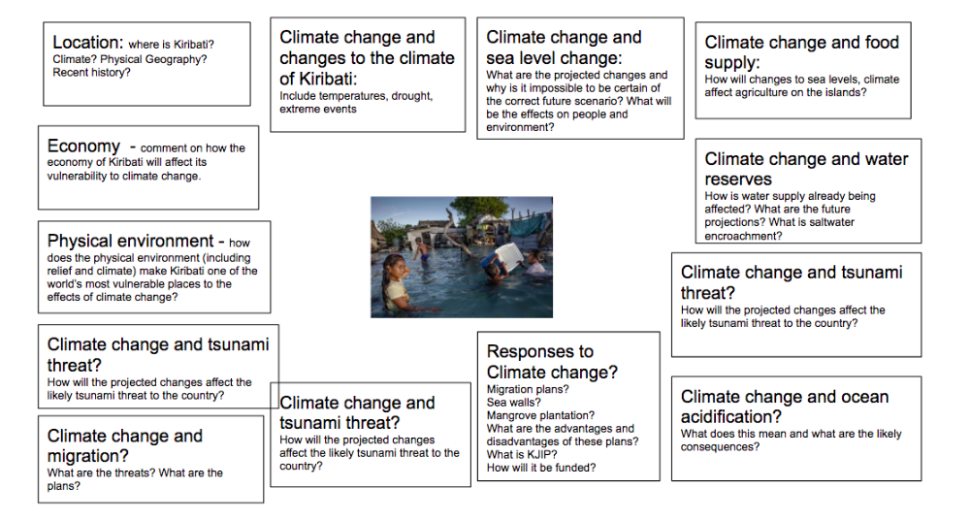

Introduction to Kiribati
Describe Kiribati’s location
What is Kiribati’s physical geography like?
Take bullet points on the basics of Kiribati’s population and economy
What factors make Kiribati vulnerable to the impacts of climate change?

Kiribati’s Climate
Use this website http://www.climate.gov.ki/changing-climate/ to:
Describe Kiribati’s current climate
Identify likely future changes to Kiribati’s climate

Impacts of Climate Change
Use this webpage to identify impacts of climate change: http://www.climate.gov.ki/category/effects/
Agriculture:
Coastal Erosion:
Economy:
Health:
Water:
Society:

Responding to Climate Change
Take notes on actions Kiribati is taking towards climate change
Mitigation
Adaptation
Relocation

Migration Strategies
Take notes on migration from Kiribati, in particular, the migration with dignity strategy (there is a link on adorngeo to this)

