Reading - Distribution of Geophysical Hazards

Distribution Patterns of Earthquakes and Volcanoes: The following map shows the pattern of earthquakes and volcanoes in the world. It shows a clear linear distribution in the world. Earthquakes occur more frequently than volcanoes and they are more widely distributed. The distribution of earthquakes is closely linked to all plate boundaries as well as plate boundary zones. The distribution of volcanoes is restricted to isolated locations along divergent boundaries and convergent boundaries where subduction occurs as well as hotspots.
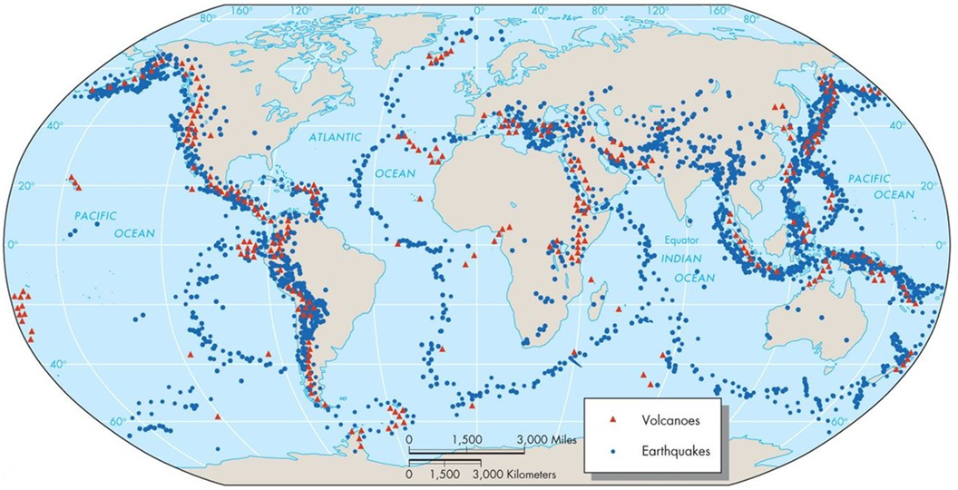

The following map shows earthquakes and volcanoes overlaid on a world map of plate boundaries. As the map shows, earthquakes occur at all plate boundaries as well as on plate boundary zones that can extend 3,000 to 4,000 kilometres away from the boundary. Divergent plate boundaries such as the Mid Atlantic Ridge also have multiple transform faults that run perpendicular to the main ridge that earthquakes occur along. 90% of the world's earthquakes occur at the Pacific Ring of Fire and earthquakes occur most frequently along conservative plate boundaries such as the San Andreas Fault in California. The most powerful earthquakes occur at subduction zones. The majority of the Ring of Fire is subduction. 75% of all volcanoes occur at subduction zones along the Pacific Ring of Fire. There are also a small number of volcanoes found at divergent plate boundaries as well as at hotspots where fixed mantle plumes can be found.

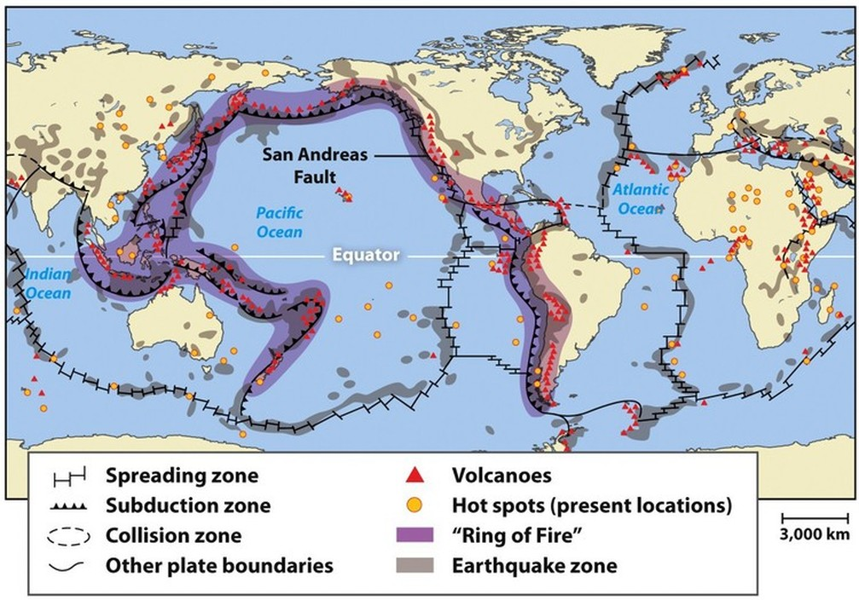

Volcanoes - Explosivity and Recurrence: Most volcanic activity takes place at convergent boundaries, where one plate is subducted under another. This may be oceanic to oceanic or oceanic to continental. In the former, submarine volcanoes erupt to produce island arcs, like that of the Aleutian Island Arc off Alaska. Oceanic to continental subduction produces significant volcanic mountain ranges such as the Andes, which forms from the subducting Nazca plate under South America. Subduction at convergent boundaries leads to composite volcanoes that have low frequency eruptions but can be very explosive. These are the result of high silicate magma rising upwards through the continental crust. Volcanoes also form at hotspots and divergent plate boundaries, where shield volcanoes are more common. Shield volcanoes like that of Mauna Loa in Hawaii are low in silica and produce fast flowing low viscosity lava. Shield volcanoes have high frequency eruptions but tend to have much lower explosivity compared to composite volcanoes.

Earthquakes, Magnitude and Recurrence: Earthquakes occur at all plate boundaries and also occur within vast plate boundary zones that can stretch several thousand kilometers away from the boundary, along transform faults and associated micro faults. High frequency - low magnitude earthquakes are more associated with conservative plate boundaries such as the San Andreas Fault in California. Low magnitude earthquake therefore have high recurrence intervals. These earthquakes tend to be shallow and low in magnitude. Conservative boundaries can also produce much higher magnitude earthquakes but at lower recurrence intervals. The Pacific Ring of Fire is not only associated with its explosive volcanic activity but also with high magnitude earthquakes. In addition some geologists argue that the highest magnitude earthquakes tend to come in twos; although there is limited statistical evidence to support this. What is clear, is that large earthquakes often cluster with many aftershocks, some of which can be almost as severe as the first.

Landslides: Landslides can occur anywhere in the world but there is a higher risk in steep mountainous regions with coarse soil. Landslide risk is greatest in populated regions with high rainfall events, such as tropical storms and lead to slope saturation and river flooding. The map below shows that greater risk of landslides links closely to mountain regions. Western regions of the Americas, East Asia and South East Asia stand out as regions of high risk. In addition, regions experiencing population pressure, deforestation, road construction, mining and plantations all lead to greater risk of landslides.
